**About the Job:**

*Hello! This is a quick form for what needs to be completed in order to test what you would be best suited for.*

*Below are the positions available, designers are paid the most and rely solely on design level. If you are selected for a enactor don't worry we will train you to also create designs in the future.*

1. *Designer - designs website templates (Just homepages all day)*
2. *Enactor - Takes templates and turns them into full websites.*
   1. *Also does Small Website Updates as requested by clients*

This Application gives you two chances to get hired either as a designer or enactor so please do both!

USE COPYRIGHT FREE IMAGES FOR EVERYTHING.

**Task 1:**  **Create 2 Templates of a home page for the following site description. You can create these in either Adobe XD or Figma. Share them via the share button and by sending the file to Vicente on Whatsapp +1 941 787 4206**

* Clients Website is a Software Company named “ Supernova ”
* Wants website logo Colors which is attached in the dropbox.
* Needs lots of call to action buttons.
* Client will provide wording so just use fake words to fill up the text.
* Pages required (ONLY SHOW THESE ON HEADER DON'T ACTUALLY MAKE).
  + Home
  + Our Vision
  + Services
  + Products
  + Media
  + Contact Us

**Task 2:** **This template has been created for you please make this in wix (just the home page and your vision of a services page.)**

(File in dropbox)

To submit this task publish the link and also share editor permission with Vicente. Make sure to name the website your first and last name.

To Share editing permissions follow these steps

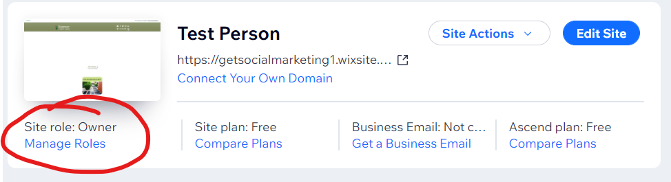

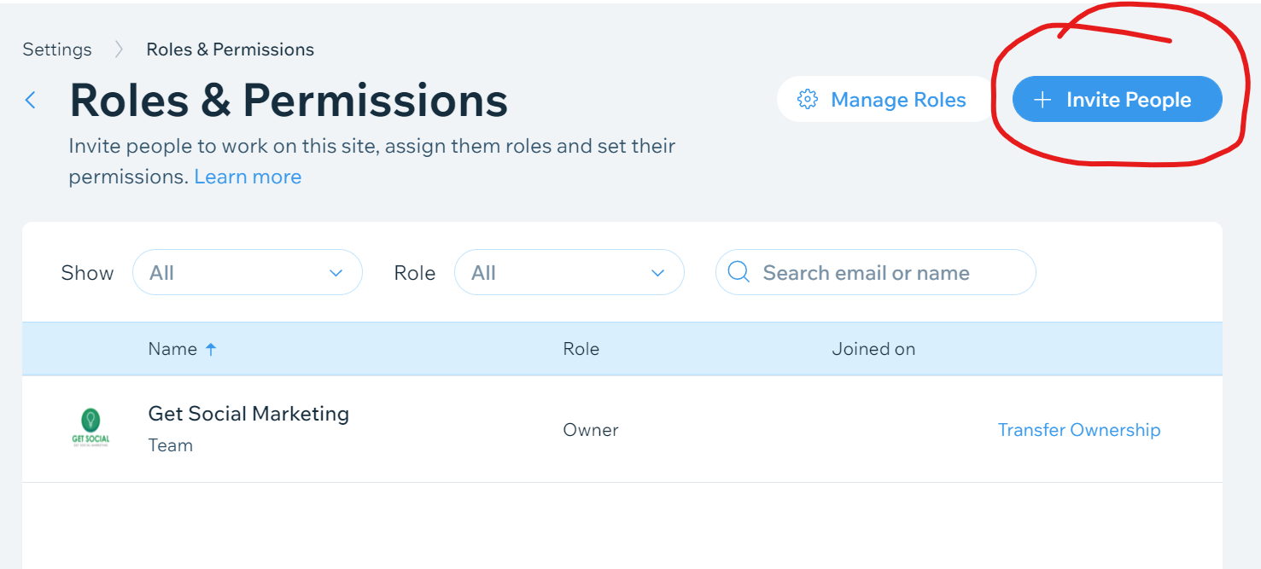

Add the email address admin@getsocial.marketing and check the box for Admin (Co-owner) then click send invite.

